MCj04105950000[1]

THE OPTI CHRONICLE

#### WE’RE 4 KIDS



**Vol. 74 No. 9 JUNE 2018**

**Atlantic Central District**

**Optimist Club of Lancaster**

**02170**

**Zone 7**

# PO Box 1215

Lancaster PA 17608-1215

Phone: 717-569-7925

# Officers 2017-2018

President Ginny DiBerardino

Past President Allen Morehead

Vice Presidents Susan Mattox

Doug Milliken

Secretary Marion Dourte

Treasurer Allen Morehead

Asst. Treas. Donna Richards

**Board of Directors:**

Two Year Roberta Myers

Ruth Morehead

Peg Sampson

One Year Tana Pratt

Bob Ruof

Marti Martin

Sergeant-at-Arms Paul Hilton

Bulletin Editor Marion Dourte

Meetings held every Tuesday 12:10 PM The Elks

Board 4th Wednesday 6:30 pm at Morehead’s

ALL WELCOME

**~ ~ ~ ~ ~ ~ ~ ~ ~ ~ ~ ~ ~**

**Happy Birthday**

***Celebrate ~ Don’t Count***

*JUNE – None that I know of!*

MC900021368[1]

**SUB ORDERS**

JUNE 14 – Orders to Kathy

JUNE 21 – Sub deliveries – Pick-Up Boas 7:30 – 9:30 a.m.

How people treat others is a direct reflection of how they feel themselves.

* Hoda Kotb

*PROGRAMS & ACTIVITIES*

**29** – Steve Lisk, Head Master at Lancaster Country Day will be our speaker.

**June 5**: Jude Pringle – Lancaster Recreation Camp Optimist.

**June 12** – NO club meeting – 6 p.m. Zone Meeting at Centerville Diner.

**June 19** – Notes to Lumina Campers

**June 26** – Welcome Bags – need 30 hand towels, washcloths, hair brushes, razors, night lights.

June 27 – Board Meeting

**PROGRAMS UP DATES:**

**PHOTO WINNERS:**

We won FIRST and second place in the Atlantic Central District contest.

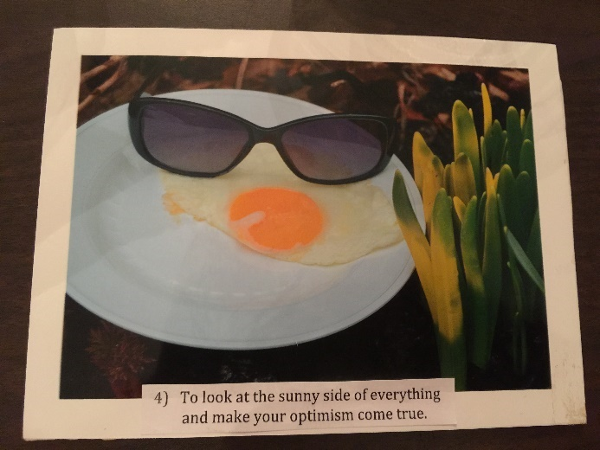

**YOUTH APPRECIATION BANQUET**:

8 May 2018 we honored 33 students from 17 schools in Lancaster County. 15 Optimist joined the students and their guests at the Banquet. We had a total of 104 attend the event. The students had a wide variety of community activities. Each student was awarded a certificate and an Optimist pen.

Dillon Marsh, Lancaster Catholic High School and Emily Mellinger, Solanco High School were awarded the Harold U. “Bucky” Mumma Memorial Youth Citizenship Award.

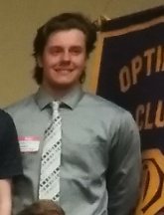**Dillon Marsh** is very active at Lancaster Catholic HS. He participates in the National Honor Society, Spanish National Honor Society, Baseball and School Ambassador for shadowing and tutoring. His community service include Emerald Foundation events, Never Ever Give Up Pediatric Cancer Foundation, Baseball camps for students, and various clean up the activities in and around Lancaster and Elizabethtown. Marsh also spoke to many classes about his Diabetic condition. He participated in two videoed programs for Children’s Hospital of Philadelphia one encouraging young people to achieve their goals and another involved sports and how the diagnosis should not limit the young person’s sports activities. He will be attending University of Kentucky on a Baseball scholarship. He will study accounting. He desires to get a Master’s degree in Forensic Accounting with a career goal of working for the FBI or Secret Service.

**Emily Mellinger** is very active at Solanco HS. She completed over 500 hours in volunteer activities during her HS career. She community activities include after school tutoring at elementary and middle schools, tutored Spanish at the HS level, assisted in Special Needs student’s Ophelia Day, volunteered at Summer Camps for Horseback riding, volunteers at a horse stable that provides Horse therapy for various clients, community Easter Egg hunts, helped at various elementary school carnivals. She assisted in the SECA auction that raises monies for the Quarryville area recreational activities. She completed three internships during her Senior year. She participated in National Honor Society and Spanish Honor Society and various activities for this group and served as an officer. She was in FFA, band, Junior coach for Girls in Track, helped to organize the Solanco Minithon. Mellinger is planning to attend Penn State, Berks campus and then transfer to main campus. She is the first person from her family to attend college. She is undecided on her major, but knows her degree will be towards a career where she can help others.

**OPTIMIST QUEEN ESSAY**

**What Optimism Means to Me—Lauren Novosat**

One of the most important aspects of optimism, I would argue, is the spreading of an internalized joy and hopefulness to others. At my school, I am the head of our FCS (Fellowship of Christian Students) club, and our main mission is to promote the spiritual wellbeing of the student; we do so through creating a close and lighthearted community in which we can share any burdens that have been weighing us down. Because I have the opportunity to serve as the head of this group, it is very important that I, as an individual, understand what optimism means so that I can share that with my peers. To many, optimism simply means happiness and unconditional cheeriness. I consider this to be only a part of the true meaning of optimism. Personally, I view optimism as a way of life that includes keeping an open mind and an impartial viewpoint. I try my best to embody this lifestyle in my everyday experience, regardless of whether the day is going as expected or not. Sometimes the aspect of impartiality is difficult, especially with our current political standings. It seems as if our country is so divided that, in conversation, I have to remind myself to keep an open mind and hear others’ opinions, even if they differ from my own. That being said, being an optimist can be difficult, especially in the face of challenge, but because it is a lifestyle I have been living for so long, I can remind myself to be positive, open-minded, and kind. While optimism is not limited to happiness and positivity, they still are a major part of what optimism is. Having a positive outlook takes effort, sometimes, when it seems as if everything is going wrong and the chances of it getting better are slim. However, with a positive outlook, I have found that every time I face hardship, it is easier to come out of it with an uplifting attitude than it would have been had I been negative and pessimistic about the outcome. With all this being said, optimism has an underlying notion of positive and proactive change. Both optimists and pessimists can look at a situation and see it two different ways—think glass half-empty and glass half-full. To be optimistic, one must see what needs to change and have the positive drive to change it, all the while retaining confidence in the future outcome. To inspire the next generation of optimists is what we need—a group of people that has the drive and the inspiration and the confidence to see what needs to be changed and then finds the motivation to move towards a new state; that can spread happiness to the people around them; that can view the world we live in with an open mind and an open heart.

**CLUB UPDATES:**

At our recent board meeting we voted to Member Emeriti due to their long standing relationship with our club; Grace Ott and Doc Stauffer. We are pleased to elevate them.

**The Optimist Creed**

***Promise Yourself ~***

To be so strong that nothing can disturb your peace of mind.

To talk health, happiness and prosperity to every person you meet.

To make all your friends feel that there is something in them.

To look at the sunny side of everything and make your optimism come true

To think only of the best, to work only for the best and to expect only the best.

To be just as enthusiastic about the success of others as you are about your own.

To forget the mistakes of the past and press on to the greater achievements of the future.

To wear a cheerful countenance at all times and give every living creature you meet a smile.

To give so much time to the improvement

of yourself that you have no time to

criticize others.

To be too large for worry, too noble for anger, too strong for fear and too happy to permit the presence of trouble.

OPTIMIST INTERNATIONAL

~ ~ ~ ~ ~

OPTIMIST CLUB OF LANCASTER

P. O. BOX 1215

LANCASTER, PA 17608-1215

OPTIMIST NEWS

We want to share it !